Experiment – Stationery Coins
Diagram:

Now answer these questions
- What happened to the coin? _______________________________________________________________________________________________________________________________________________________________________________________________________________________________________________________________________________________________________________________________________________________________________________________

- We can say the coin did not move with the paper because it had _________________.
- State one of Newton’s laws of motion that fits with this experiment:
_______________________________________________________________________________
_______________________________________________________________________________

- Watch the clip of the tablecloth. Describe what happens using science ideas
__________________________________________________________________________________________________________________________________________________________________________________________________________________________________________________________________________________________________________________________________________________________________________________________________________________________________________________________________________________________
- In the picture below what is behaving similar to the coin in your experiment?
This diagram show the movement of person on a train.

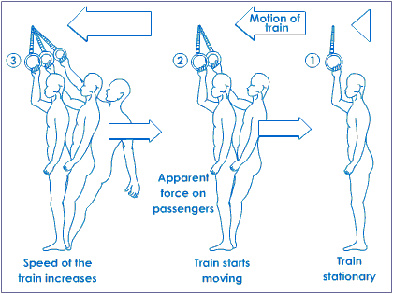

__________________________________________________________________________________________________________________________________________________________________________________________________________________________________________________________________________________________________________________________________________________________________________________________________________________________________________________________________________________________

Newton’s Laws of Motion | Definition
1st | An object at rest will remain at rest unless acted on by a f________.  An object that is moving will continue to _________ with the same speed and in the same direction unless acted upon by a force.  This law is often called  "the law of i__________".
2nd | An object will accelerate in the _________________ of an unbalanced force acting upon it. The amount of acceleration depends on the mass of the _____________ and the amount of ___________ acting on it.
3rd | For every action force there is an opposite and equal _________ force.

Which law of Motion is shown in the picture? | Picture
 | 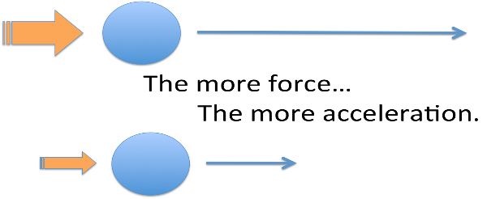
 | - 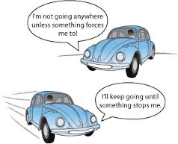
 | 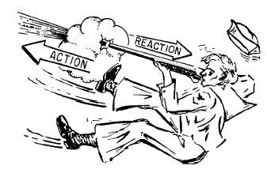
 | 
   

